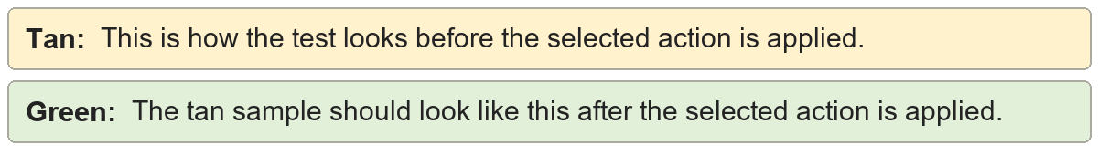
Consecutive empty paragraphs | Two content lines use paragraph spacing.

Second content line.
Consecutive empty paragraphs | Two content lines use paragraph spacing.

Second content line.

Soft returns to paragraph marks | First line
Second line
Third line
Soft returns to paragraph marks | First line
Second line
Third line

Paragraph spacing | This paragraph uses extra Space Before and Space After.
Paragraph spacing | This paragraph uses extra Space Before and Space After.

Manual tab indentation | This line starts with a manual tab.
Manual tab indentation | This line starts with a manual tab.

Manual space indentation | This line starts with manual spaces.
Manual space indentation | This line starts with manual spaces.

